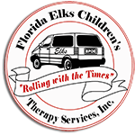
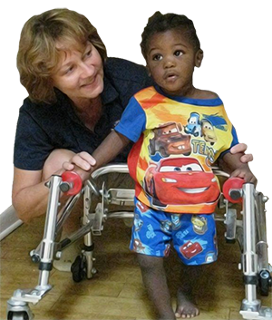
Helping Children Develop and Grow

Celebrating Mobile In-Home Therapy Services Since 1999
Florida Elks Children's Therapy Services provides in-home physical therapy and occupational therapy to Florida children. Priority is given to children in need whose families have limited financial resources and would not otherwise have ready access to these therapy services.
Therapists are employed by the Florida Elks and are licensed to practice by the state of Florida. With 29 mobile units, our therapists are treating children throughout the state covering most of its 67 counties. Therapist see about 535 Children a week.
The services received by patients who meet eligibility requirements are absolutely free. We do not receive financial assistance from any level of government. Instead, we receive our funding from the Harry-Anna Charitable Trust as well as our Elks lodges, various Florida Elks ladies organizations, the Elks National Foundation, and most importantly, from generous public donations.

