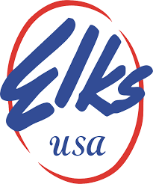
Hollywood West Elks Lodge # 2365 7190 Davie Road Ext Hollywood, FL 33024

Initiation Night

Thursday, August 6, 2020 – 7:30 pm
Arrive by 7 pm
Dressed properly ( no shorts )

