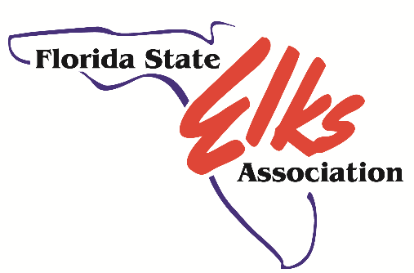

NEW MEMBER ORIENTATION
Welcome New Members
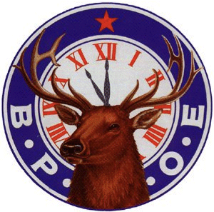

Prepared by: FSEA
Orientation Committee
Update July 2020 by Jim Blanchard
AGENDA
- Opening Observance
- Openings Remarks And Introductions
- A Brief History of The Elks
- Elks National, State And Local Lodge Structure
- National and State Projects – Video Presentations
– DiscussionofElksNationalFoundation(ENF)
– DiscussionofYouthCampandTherapyServices
- Local Lodge Committees
- Local Lodge Special Projects and Social Activities
- The Initiation Ritual
- Lodge Etiquette
- Your Role
- Question And Answer Period
- Closing Remarks
- Closing Observance

Orientation Session Opening
- Opening observance
- Orientation Chairman’s welcoming remarks - Introduction of candidates, sponsors and guests
- Introduction of officers and committee chairman

A Brief History Of The Elks
In February 1868, a group of fifteen founders, who were entertainers known as the "Jolly Corks“, created what is now known as the Benevolent and Protective Order of Elks. With a statement of serious purpose, an impressive set of rituals, a symbol of strength and majesty as well as such other elaborate trappings that might be expected of a group of actors and musicians, the new fraternal order was launched.
Since its founding the Benevolent and Protective Order of Elks (BPOE) has been recognized by the noble creature that is the symbol of the Order. The Elk is a peaceful animal, but will rise in defense of its own in the face of a threat. The majestic creature is fleet of foot and keen of perception.

Benevolent and Protective Order Of Elks
- Membership is open to adult American citizens
- Almost 2000 Lodges in all 50 States and possessions ( Philippines, Puerto Rico, Panama Canal )
- Is a not-for-profit fraternal order founded upon the principles of Charity, Justice, Brotherly Love and Fidelity

Benevolent and Protective Order Of Elks
Structure similar to Federal and State Government
National: Grand Exalted Ruler, represented by Florida State Sponsors Robert Grafton and Michael Smith
• District Deputy Grand Exalted Ruler (DDGER) representation
State: Florida State Elks Association State (FSEA) supporting state charitable projects
• President, Vice President at Large and District Vice Presidents
More information at www.floridaelks.org and www.elks.org

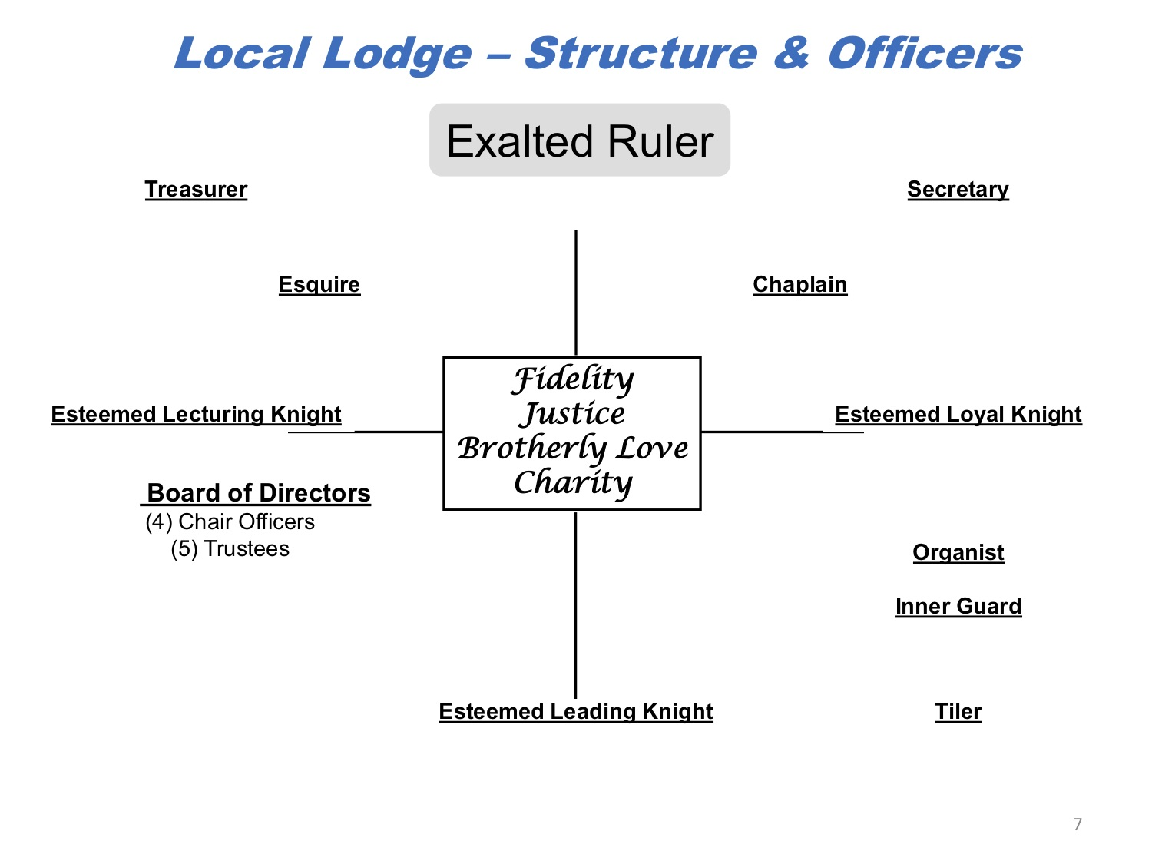
National And State Major Projects
- Grand Lodge and Florida State Elks Association videos
- Discussion of Elks National Foundation
- Discussion of FSEA Youth Camp and Children’s Therapy Services
- Elks relationship and support of veterans and military families
The Elks pledge: "So long as there are veterans, the Benevolent and Protective Order of Elks will never forget them”

Local Lodge Committees
- Officers – Overall Lodge operations, oversee bar, kitchen and club, conduct meetings and Rituals
- Board of Directors (or Board of Trustees) – Property, assets budget, expenditure management
- House Committee – Day-to-day operation of bar, kitchen and Lodge activities
- Membership Committee – New applications, lapsation
- Youth activities, veterans, drug awareness and other projects
- Sickness & distress
- Special purpose committees

Local Lodge Special Projects
& Social Programs
- Support to Elks National Foundation and Florida’s major projects – FloridaElksChildren’sTherapyServices-mobiletherapy – FloridaElksYouthCamp-summercampinUmatilla
- Youth Activities (Hoop Shoot) Drug Awareness
- Army of Hope - veterans and military families support
- Youth scholarships – ENF, Hope, Van Duren
- Golf and softball tournaments to benefit charities
- Dinner dances, karaoke, trivia family dinner nights and bingo
- Thanksgiving, Halloween, New Year’s Eve, Super Bowl Sunday, St. Patrick’s, and much more
- Special Rituals – Flag Day, Mothers Day, Dec Memorial etc.
- 11 O'clock Toast in remembrance of departed Members
- Spouse’s organizations
Initiation to Membership
- An Important occasion for you and the Lodge
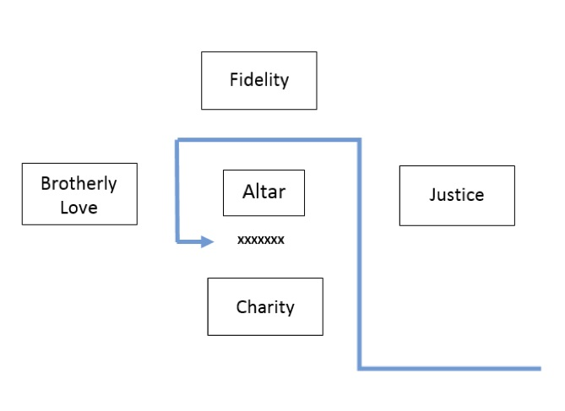
- Dress appropriately, business attire
- Arrive 1⁄2 hour before the meeting
- Esquire will brief you before meeting begins
- Esquire will escort you into the Lodge
- Be attentive , follow directions of Lodge Esquire
- Take the Solemn and Binding Obligation (Ritual)
- After Oath, you are Members in Good Standing
- Present brief overview of yourself (1 to 2 minutes)

Lodge Etiquette
- Read & follow our House Rules.
- Guests must be signed in on our Guest Book.
- No profanity. Wear appropriate dress.
- Be friendly & courteous.
- Welcome our out-of-town Elk guests.
- Bartenders are in charge. Listen to them.
- Be proud to show your membership card when asked
- Help us create a friendly, family atmosphere. “The Faults of our Members we write upon the Sand, their Virtues upon the Tablets of Love and Memory”

Your Role
• Volunteer some of your time
• Get involved
• Visit the Lodge often
• Attend Lodge meetings
• Eat, drink, enjoy
• Tell others about the Elks

Orientation Session Closing
- Question and answer period
- Request for closing comments from officers and chairman
- Closing observance
- Session closed

