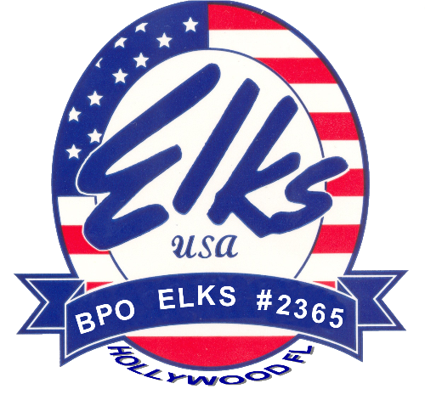

Hollywood West
Elks Lodge #2365
New Member
Information Packet

Hollywood West Elks Lodge #2365
Updated: July 8, 2020
A Brief History of The Elks
A Short History of the Benevolent and Protective Order of the Elk (BPOE)

On November 15, 1867 a small group of actors and entertainers, lead by an English comedy singer named Charles Algernon Sidney Vivian, organized a drinking club in New York City. They called their newly formed organization the "Jolly Corks". Vivian adopted the name "Jolly Corks" from a bar-game he played while in England. The sole purpose of the "Jolly Corks" organization was to circumvent a New York law that closed saloons on Sundays.

Vivian's group, with their initial intentions of promoting fellowship among entertainers, quickly saw the benefits they could bring not only to themselves but to others less fortunate.

Charles Vivian, noted for his wit and personality, served as the moving force when the Jolly Corks organized. As the Jolly Corks membership shifted to more serious minded individuals, George McDonald, joined the organization. Mr. McDonald and others felt there was a need for a benevolent society for the theatrical world. This catapulted the mission of the Jolly Corks into a fraternal, charitable, and service oriented organization.

In 1868, through the efforts these benevolent individuals "The Jolly Corks" was renamed The Benevolent and Protective Order of Elks of The United States Of America (BPOE), or simply "Elks".

Such men as Charles Vivian and George McDonald gave the Elks its real organization and serious purpose, and also preventing it from fragmenting or going out of business.

The name 'Elk' was selected because the Elk has a number of attributes that are deemed typical of those to be cultivated by members of the fraternity. The Elk is distinctively an American animal. It habitually lives in herds. The Elk is the largest of our native quadrupeds, it is yet fleet of foot and graceful in movement. It is quick and keen of perception; and while it is usually gentle and even timorous, it is strong and valiant in defense of its own.

The lessons taught by the Elks are communicated by short lectures. Included in Elk Lodge ceremonies are the Bible and the American Flag. Emblems associated with the Elks are: the flower called the 'Forget-Me-Not'; Antlers of Protection; and the Star of Fidelity.

The cardinal principals of the Elks are: Brotherly Love, Justice, Charity, and Fidelity. The Elks also take deserved pride in their patriotic and charitable endeavors.

The first Elk Lodge is located in New York and opened on March 12, 1871.

If we fast forward to 2003 we find that there are over 1 million members of the fraternity and over 2,100 Elk lodges throughout the United States, Puerto Rico, Guam, and other US Possessions.

Lodge History

Hollywood West Elks Lodge 2365
South Southeast District
Dispensation: January 23, 1967
Charter granted: March 31, 1967
Charter Exalted Ruler: Bernard Dolan

http://www.elkslodge2365.org/
then select: More Info tab
then select: lodge history link

Elks National Foundation –ENF
Our Legacy to the Future

Our Mission
The mission of the ENF is to help Elks build stronger communities. We fulfill this pledge by investing in communities where Elks live and work. We provide tomorrow's leaders, our youth, with lifelong skills; honor the Elks' pledge to never forget our veterans; help the state Elks associations accomplish their charitable objectives; and fund projects that improve the quality of life in local Elks communities.
Our Impact
Since inception, the ENF has contributed more than $500 million toward Elks charitable projects nationwide. These funds enable programs that support youth, honor veterans, and meet needs in areas where Elks live and work. Our programs continue to grow each year, allowing Elks to do even more to build stronger communities. Click here for details on all ENF programs.
This year, the ENF allocated $14.6 million to fund the Community Investments Program, investing in Elks communities through grants for Elks Lodges. Community Investments Program grants—which include Beacon, Gratitude, Promise and Impact grants—offer your Lodge an opportunity to serve your community in ways that will raise the Lodge’s profile, energize the membership, encourage former members to return to the fold, and gain the notice of people who want to be part of an organization that’s doing great things.
How the ENF Works
The ENF is able to help Elks build stronger communities thanks to contributions from our generous donors. Since inception, we have received more than $270 million in contributions and bequests. Today we boast more than 150,000 active donors and an endowment fund valued at $682.9 million.
A board of seven trustees, who are all past national presidents of the Order, governs the ENF, which is located at the Elks national headquarters in the Elks Veterans Memorial in Chicago.
Harry-Anna Trust Fund

Florida Elks Charitable Trust
Together We Can Do Great Things
Of everything that the Florida Elks do, perhaps nothing is more important than our work with the state’s youth. Sowing the seeds of accomplishment and commitment through our Florida Elks Children’s Therapy Services and Florida Elks Youth Camp programs, children are given the opportunity to grow and learn beyond their wildest imaginations.
Known to Florida Elks as the Harry-Anna Trust Fund, named after Harry and Anna Miller who donated land and a building to establish the original Florida Elks Hospital for Crippled Children, the trust was started in 1951. The purpose of this charitable trust was, and continues to be, the collection of donations, the selling of trust fund certificates, and the acceptance of endowed gifts.
The trust fund is restricted, which means that only the income derived from it may be used to support our major projects: the Florida Elks Children’s Therapy Services and Florida Elks Youth Camp programs.

Federal Tax Savings
A contribution to the trust fund is a tax deductible donation to a U.S. tax code 501(c)(3) organization.

You can also donate to the Army of Hope and the
C. Valentine Bates HOPE Scholarship through the
Elks Florida Charities Fund.
Children's Therapy Services

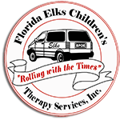
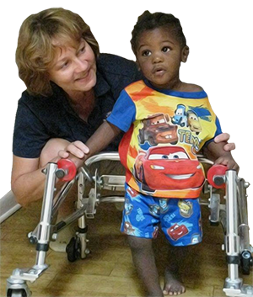
Helping Children Develop and Grow

Celebrating Mobile In-Home Therapy Services Since 1999
Florida Elks Children's Therapy Services provides in-home physical therapy and occupational therapy to Florida children. Priority is given to children in need whose families have limited financial resources and would not otherwise have ready access to these therapy services.
Therapists are employed by the Florida Elks and are licensed to practice by the state of Florida. With 25 mobile units, our therapists are treating children throughout the state covering most of its 67 counties.

The services received by patients who meet eligibility requirements are absolutely free. We do not receive financial assistance from any level of government. Instead, we receive our funding from the Harry-Anna Charitable Trust as well as our Elks lodges, various Florida Elks ladies organizations, the Elks National Foundation, and most importantly, from generous public donations.

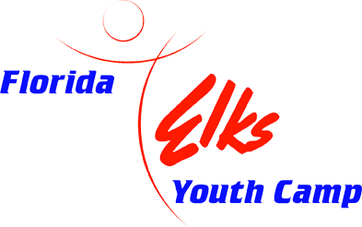
Youth Camp
Enriching Lives of Kids

The Florida Elks Youth Camp is dedicated to enriching the lives of children from the state of Florida. The camp staff presents a safe camp experience that contributes to each camper's mental, physical, and social growth. The Florida Elks Youth Camp, a project of the Florida State Elks Association, is located on 405 acres of rolling hills, forests, lakes, and open space in Marion County, Florida. The Florida Elks are proud that our camp is accredited by the American Camping Association and is recertified every three years to assure compliance and a safe camping environment for children.
The camp has a ratio of one counselor and one counselor in training to every seven campers. The camp opened its doors in 1991 to all of the children of Florida and has played a pivotal role in the development of so many children. It offers them countless opportunities that have not previously been available to them. Their team-building skills are improved, they have access to state of the art recreational equipment, and they have a chance to enjoy themselves in a caring, social setting where the good of the children is always the priority.
Who uses the camp? We offer summer camp opportunities to any Florida child as well as Elks' children and grandchildren at a modest cost for one or two weeks. However, we don't turn away those unable to pay. Additionally, the camp is used year-round by a wide variety of organizations dedicated to enriching the lives of children in general and underprivileged and disabled children in particular.
The camp has become one of the finest of its kind in the country. It is already a facility that Florida Elks take pride in, and it is a popular place for Florida's young people, as thousands use it every year. We hope that, at some point, you are able to visit the youth camp when
visiting in the area.

What it Means to be an Elk in Florida

For over 140 years, the Benevolent and Protective Order of the Elks has been dedicated to serving our fellow citizens.
Here in Florida, the 56,000 men and women of the Elks in 100 Lodges from the panhandle to the Keys are enjoying the camaraderie, compassion, community outreach, and support that are all part of being an Elk.
Although you may already be aware of the social benefits of our great fraternal organization, you may not know that each Lodge has its own unique amenities. Florida Elks enjoy indoor and outdoor sports activities, entertainment, parties, dances, dining, and much more.
More importantly, Florida Elks take great pride in giving back to our communities. Nationally, each year, the nearly one million Elks working together with the Elks National Foundation provide over $80 million for charitable programs such as the Hoop Shoot competition, scholarships, drug awareness in our schools, and assistance for veterans of all wars.
In Florida alone, Elks provide millions of dollars in assistance to the neediest among us:
- The Army of Hope provides assistance to veterans and military families
- The Elks Children’s Therapy Program brings mobile, in-home therapy services to children across the state
- The 400-acre Elks Youth Camp in Umatilla builds character while simultaneously inspiring Florida’s youth by teaching respect and responsibility
As a member of our order, you will be supporting all of these programs while enjoying all of the benefits of being an Elk.
If you are looking for something meaningful that truly makes a difference in your local community and the lives of others, and if you and your spouse want to meet new and interesting people who share your values and commitments to our country, then you’ve found it.
We hope that you’ll take that next step and make the Florida Elks part of the next chapter in your life. Together we can do great things.
Hollywood West Elks Lodge #2365

Lodge Contacts
- Exalted Ruler: John Allison
- Secretary: JoAnn Caliendo
Cyber-Assistant: Jim Blanchard
Lodge Location
Hollywood West, FL No. 2365
7190 Davie Road Ext
Hollywood, FL 33024-2404
Lodge Mailing Address
Hollywood West, FL No. 2365
7190 Davie Road Ext
Hollywood, FL 33024-2404
Lodge Contact Information
- Telephone: (954)374-2464 (Lodge)
- Telephone: (954)963-6714 (Office)
- Telephone: (954)610-4041‬ (Emergency)‬‬‬‬‬‬
- E-mail: secelklodge2365@att.net (Lodge)
Website: http://www.elkslodge2365.org/ (Lodge)

Meetings:
Our meetings are held the 1st and 3rd Thursdays of the Month at 7:30 PM
(except June, July and August when it is only the 1st Thursday)

Lodge Hours:

Lodge Hours: Mon — Thu 2pm - 8 pm
Fri 2pm - 12 am
Sat 12pm - 8pm
Sun 12pm - 8pm
(Call for closing times after 6pm)

Lodge Facilities
- Banquet Room (available for member rental)
- Lodge Social Quarters or Lounge
- Tiki Hut
- Horseshoe Pits & Cornhole Game Boards
- Game Room - Pool Table, Card Table
- Outdoor Kitchen - BBQ Pit & Grill
- ATM & Jukebox

National website:
http://www.elks.org

State website:
Florida Elks - Florida Elks
http://www.floridaelks.org/

Lodge website:
http://www.elkslodge2365.org

11 O'Clock Toast
You have heard the tolling of 11 strokes. This is to remind us that with Elks, the hour of 11 has a tender significance. Wherever Elks may roam, whatever their lot in life may be, when this hour falls upon the dial of night, the great heart of Elkdom swells and throbs. It is the golden hour of recollection, the homecoming of those who wander, the mystic roll call of those who will come no more. Living or dead, Elks are never forgotten, never forsaken. Morning and noon may pass them by, the light of day sink heedlessly in the West, but ere the shadows of midnight shall fall, the chimes of memory will be pealing forth the friendly message, "To our absent members."

House Rules
- No one except the bartenders on duty and Members of the House Committee will be permitted behind the bar without permission.
- Profane or obscene language will not be tolerated. Persons transgressing this rule shall be asked to leave the lounge and the Club Manager shall make a factual and complete report of the incident to the House Committee.
- The Club Manager and the bartenders shall refuse service to anyone they feel is intoxicated and shall make every effort to see those people home safely.
- Checks not to exceed $50 daily, may only be cashed by Members in good standing with the Lodge at the discretion of the Club Manager or bartender. The Member’s name, address, telephone and membership number must appear on the check. If a check is returned to the Lodge for any reason, the Member will have 14 days to reimburse the Lodge.
- The lounge shall be for the enjoyment of the Members and their guests only. The bartenders on duty shall require proof of the member and to all persons not known to him or her, to be Members of the Order.
- Members will be held strictly responsible for the conduct of their guests and at any club activity said guests must be seated with the Member responsible and must leave with said Member.
- Club room will be closed for all special functions recognized by the Lodge to ticket holders only. IE: New Years Eve Party
- The bar will be closed on all Lodge meeting nights and special meetings when the Tiler informs the bartender that the meeting is about to begin. No bar service thereafter until the meeting is closed. All Lodge Members present must attend the meeting or leave the Lodge. (Spouses/guests can remain in social quarters)
- Requests for the use of the Lodge rooms and/or parts of the Club shall first be cleared with the Board of Directors. Other committees being in charge of events taking place in the Lodge shall take no action that will interfere with the powers of the House Committee or Club Manager without first obtaining approval of the same.
- All persons entering the building shall be dressed in an appropriate manner. (Decision made by Club Manager or Bartender present.)
- Bar and lounge hours are to be posted and may not be altered except by vote of the House Committee and/or at discretion of the bartender when 6 or less persons are present.
- No one under the age of 16 shall be allowed to use the pool table unless supervised by an adult.
- No minors allowed at the bar at any time. No one under the age of 18 years old will be allowed in the social quarters after 11:00 p.m. unless invited for special occasions.
- No alcoholic beverage containers from outside of the Lodge are allowed in the Lodge or Tiki Bar.
- Violations of these rules shall be reviewed by the House Committee. The House Committee, upon hearing all facts of the reported violation, shall make recommendations for final disposition. At no time shall the House Committee operate outside Grand Lodge Statutes or Lodge By-Laws which may apply in a disciplinary action.
- Appropriate uniforms will be worn by all Lodge employees. There will be three tops initially provided by Hollywood West Lodge #2365 to be worn with their own personal black pants or slacks except when authorized by Club Manager.
- All other rules which the House Committee deems necessary will be added or changed after 30 days notification to the members of Hollywood West Lodge #2365 and compliance with Grand Lodge Statute, Sec.17.060.
- No smoking or e-cigarettes is permitted within the Lodge, only in designated smoking areas on the property.
- No pets are allowed in the Lodge at any time
- The Lodge shall be considered the Lodge and all its properties.
Approved 04/24/2018

