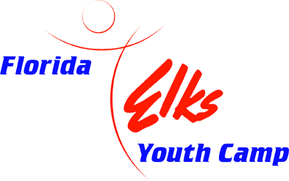
Enriching Lives of Kids

The Florida Elks Youth Camp is dedicated to enriching the lives of children from the state of Florida. The camp staff presents a safe camp experience that contributes to each camper's mental, physical, and social growth. The Florida Elks Youth Camp, a project of the Florida State Elks Association, is located on 405 acres of rolling hills, forests, lakes, and open space in Marion County, Florida. The Florida Elks are proud that our camp is accredited by the American Camping Association and is recertified every three years to assure compliance and a safe camping environment for children.
The camp has a ratio of one counselor and one counselor in training to every seven campers. The camp opened its doors in 1991 to all of the children of Florida and has played a pivotal role in the development of so many children. It offers them countless opportunities that have not previously been available to them. Their team-building skills are improved, they have access to state of the art recreational equipment, and they have a chance to enjoy themselves in a caring, social setting where the good of the children is always the priority.

Who uses the camp? We offer summer camp opportunities to any Florida child as well as Elks' children and grandchildren at a modest cost for one or two weeks. However, we don't turn away those unable to pay. Additionally, the camp is used year-round by a wide variety of organizations dedicated to enriching the lives of children in general and underprivileged and disabled children in particular.
The camp has become one of the finest of its kind in the country. It is already a facility that Florida Elks take pride in, and it is a popular place for Florida's young people, as thousands use it every year. We hope that, at some point, you are able to visit the youth camp when visiting in the area.

